1. **Functional Deliverables:**

**Screenshots or screen recordings showcasing product listing page, product detail pages and Working category filters, search bar.**

**Screen Recording Link:**

[**https://www.loom.com/share/77f656302ee248a3b62c4c702f4568ab?sid=5c8d7591-7f93-410b-8471-6982252a50f6**](https://www.loom.com/share/77f656302ee248a3b62c4c702f4568ab?sid=5c8d7591-7f93-410b-8471-6982252a50f6)

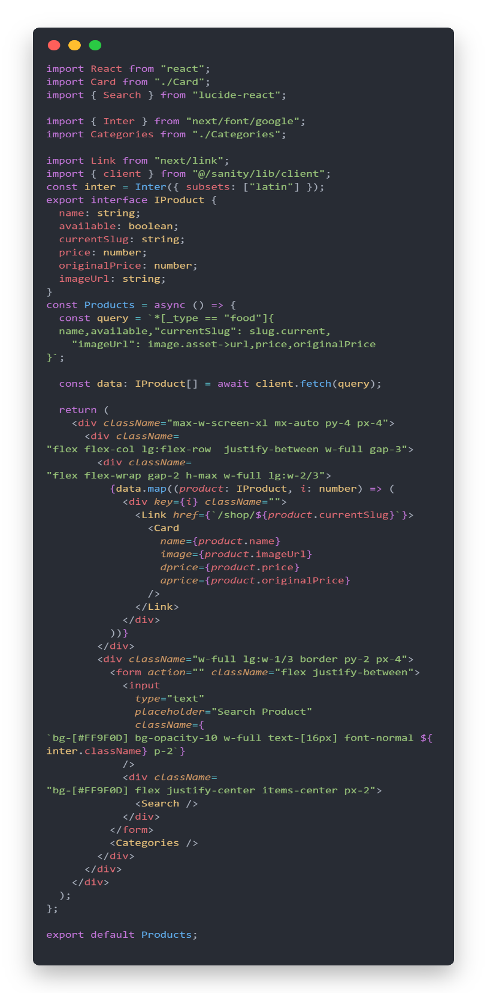

Product Detail Page

1. 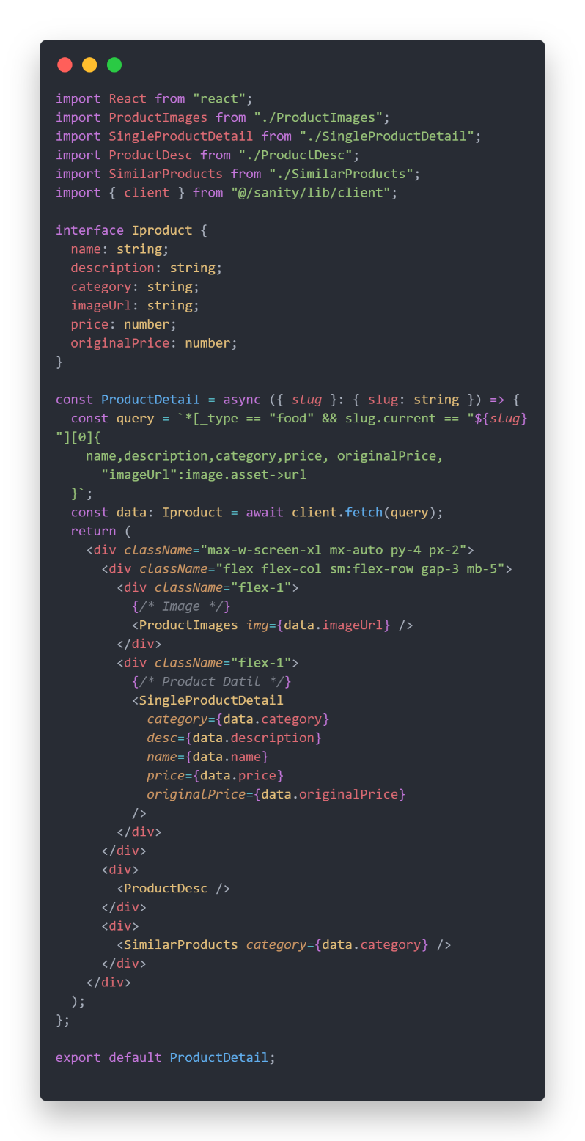**Code Deliverables:**

Product List Page

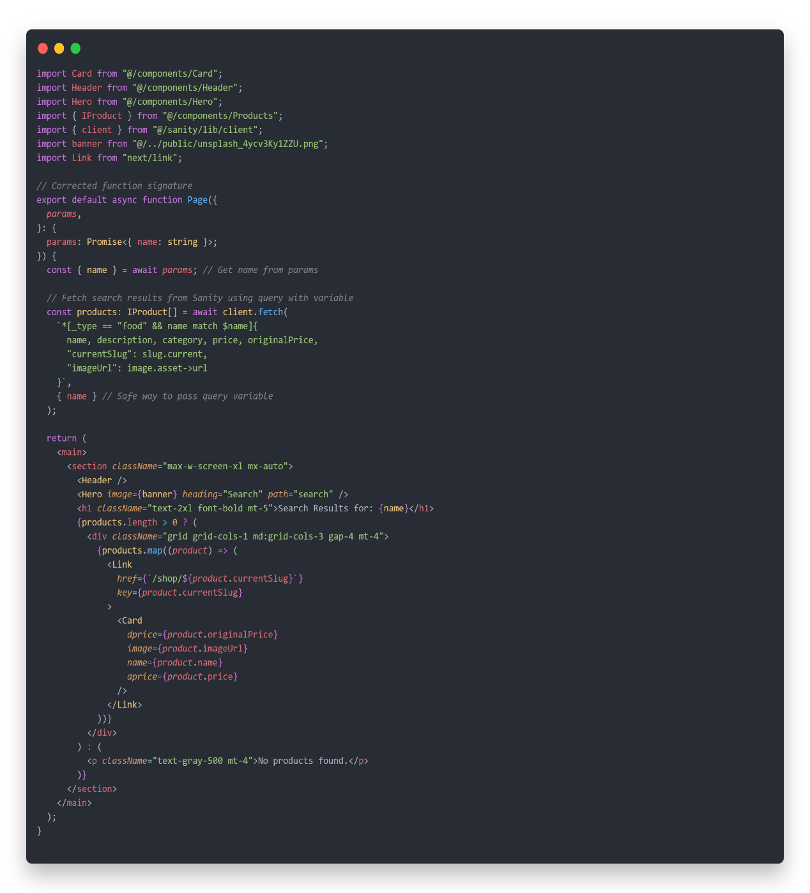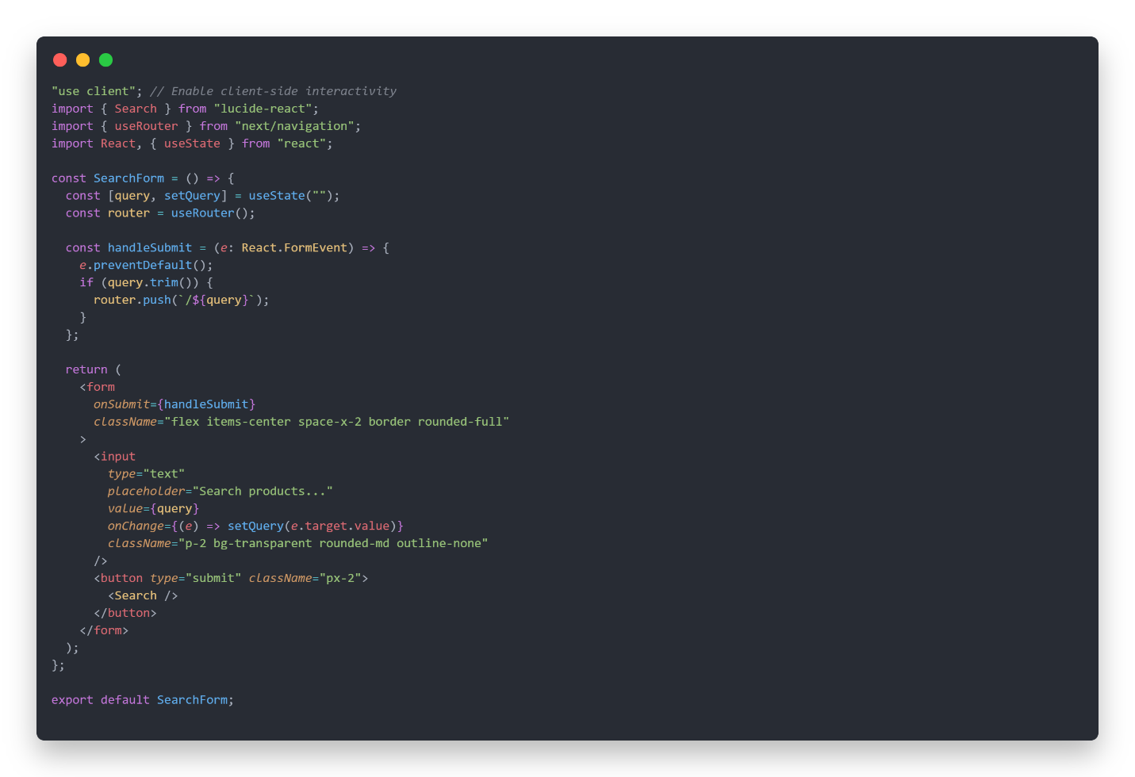

Search Page and Logic for fetch Data

Search Form Code

1. **Documentation:**

**Steps taken to build and integrate components.**

1. **Product List Page:** The product in the list page has been fetched from sanity by writing the query which is mentioned in the above code of ProductList Page.
2. **Product Detail Page:** The Single product is fetched by using the slug. The params slug is checked and compare with the product slug and when these two are matched, then that product is fetched from sanity.
3. **Search Form and Search Result:** This Search is working the same as product detail page. Input field value is gotten through params and match that with product name and when it is matched with those products in the sanity, the sanity return all those matched products.

**Challenges faced and solutions implemented.**

I have faced one challenge implementing these components. Which is because of params. The error is of Type “Type Error”. This error comes because I am using Latest next.js version which is Next.js 15. Define type of param is a promise which is resolved by wrapping type in a promise such as: Promise<{slug: string}>